Code Review: I2305178
Reviewer: Mark Dell
Date: September 22nd, 2023

Bugs

Preventative Action/Safety

Design/Architecture (Duplication, appropriate project, namespaces, maintainability)

Data Model (Naming, good design, needs index?)

Performance (Minimize DB hits, excessive loops, queries, scalable)

UI (Alignment, naming, standardization, tab order)

Error Handling (Behind events, appropriate parameter checking)

Cleanup (Dispose code, remove handlers, large data objects)

Readability (Well-named variables, methods, clear algorithm, is it understandable)
- Use of a SQLReader is not needed when ExecuteScalar will do.
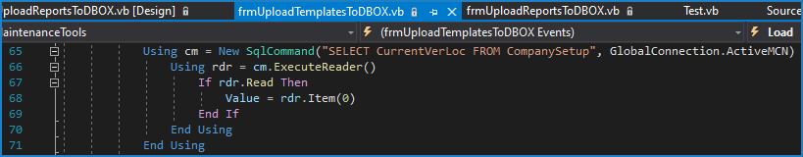
- Nit: I always use “ActiveMCM.CreateCommand()” instead of “New SqlCommand”. That way if I ever do it against a different connection class, I always get the correct command object. The disadvantage is that the CommandText can’t be specified in the command.
- Duplicate columns are created in this SQL based on a fixed value, and another column in that same SQL. This reduces readability, and implies additional complexity because where they are used in the code it appears that these may not be related. I understand that this may be because this form is based on the Reports one, and would be more understandable if the two forms were combined.
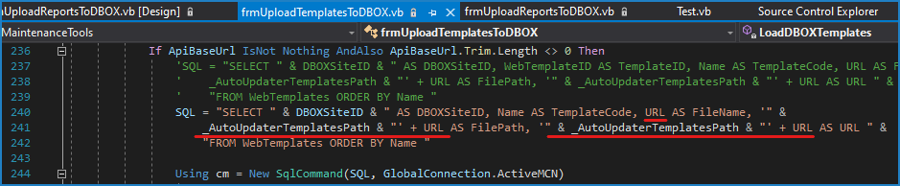
- Commented out code was left in the new form’s code. Except to very specific circumstances where a comment was included to explain why, we should no longer be doing this, even when modifying existing code.
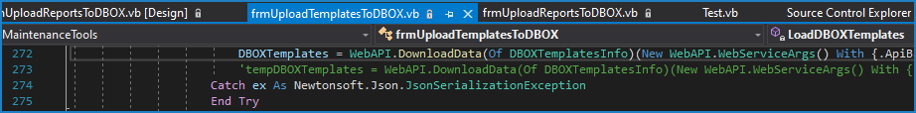

Comments (Useful, explains why rather than how)

Message Boxes (Grammar, spelling, captions, appropriate icons)

Ticket Management (Release Branch?, Testing Notes)
- This change was checked in via two separate check-ins under two different work items. Separate work items are not needed since it is the same ticket. Separate check-ins like this are not good because the AdminTools changes have made it to the Release branch without the changes to the .NET form. This must now be removed from the release branch before the AdminTools.dll can be released. If you were concerned about loosing your changes, then a shelveset would have been a better choice. If this work were done via a separate dedicated long-term branch, then this would not be a concern, but it is rare that this is done.
- The ticket requested to do this as part of the existing form, so a separate entry point should not be required. Modifying or replacing the existing access (menu) and entry points would be fine (possibly UploadCustomFilesToDBOX). It would be acceptable to leave the existing entry point in .NET in case a client receives the new .NET file, but not the caller, which is unlikely if only AdminTools calls it.
If there is a reason that this was not feasible, it should have been mentioned in the ticket. In that case, the new form is not following the new UI standards.
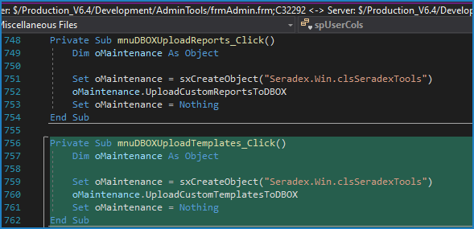

Extras
- When checking in VB6 code (and .NET designer files) you need to compare the changes to look for and remove unintentional automatic changes to the best of your ability. These could have been avoided via simple actions in VB6 or by manually manipulating the file outside of VB6. There are a few times where automatic changes are unavoidable, such as with Appearance vars in .NET designer files.
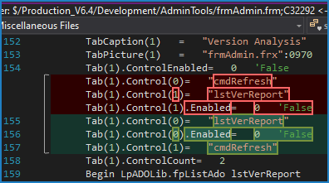
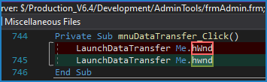
- The new form does not include the DBOX Site column in the main table which was included to add confidence to the user that the correct site was being updated. I recognize that this does not work for Golden since they have 2 sites for 1 ActiveM, but from what I know, they are the only ones.

- The Reports form was created to enable uploading for all ActiveMs, and thus can have several rows in the main table. Since the new form is showing the child table instead, the user cannot see what site they are updating. I suggest that the better solution is to show both tables in the grid, binding to the dataset instead, allowing 2 table levels to be shown.
